
Dhaka International University
Lab Report details:
Lab Report Topic : Area of circle, Sum of two numbers and Greater Number of two numbers with Java Program
Lab Report No : 03
Course Title : Object-Oriented Programming Languages
Course Code : 0613-202

Submitted By: | Submitted To:
S M Nabil Ausaf  Roll: 01  Reg No : CS-D-91-23-124492 | Prof. Md. Abdul Based

Date of Submission: ‎22-‎Oct-‎24

Code 1: Calculation of the Area of a Circle
Objective:
Creating a simple java application that calculates and displays the area of a circle with a given radius. Application of basic mathematical operations, input, and output functions shall be the basis to develop such a program.
Components Used:
1. Java program compiler : To write, compile, and run the Java program.
2. Variables:
Radius: a double variable to store the radius of the circle.
Area: a double variable to store the computed area.
3. Mathematical formula: To compute the area of the circle we use the formula:
Area =Pi or 3.1416*Radius*Radius
4. Libraries:
No external libraries; the code relies solely on standard Java packages.

Theory:
One of the basic calculations in geometry involves finding the area of a circle. This is the region enclosed by a circle and can be mathematically expressed as:
Area = π × Radius x Radius
Where:
(Pi) ≈ 3.1416.
Radius is the length from the center of the circle to any point on its perimeter. In this Java program calculates the area using the radius and then displays it. The value of Pi is approximated to 3.1416 for simplicity, but in Java, more accurate values can be obtained through the Math.PI constant.

Problem Solving Procedure:
1.Class: In Java, a class is a blueprint of an object. It comprises variables to define the characteristics of an object and methods to provide the behavior of an object.
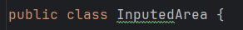
2. Declare variables: The two double variables must be declared and their names are Radius and Area.
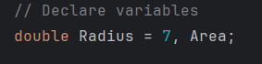
2. Applying the formula: Calculate the area by applying the formula for the area of a circle, as shown below:
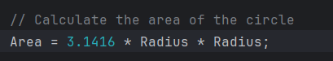

3. Printing the result: Use System.out.println() to print the area calculated.
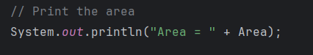
4. Compile and run the program to ensure the intended output appears.
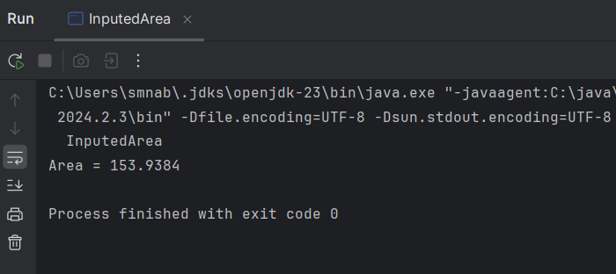
Code:
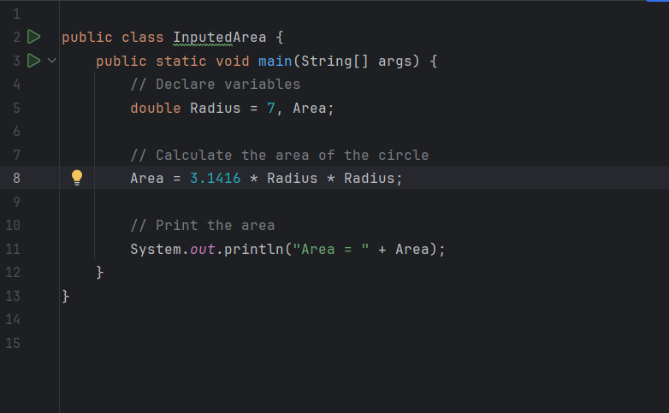

Example Input & Output:
Input: In the following program, the radius of the circle is predefined as 7.00.
Output: The program will calculate the area of the circle and print the result as:
Area = 153.9384
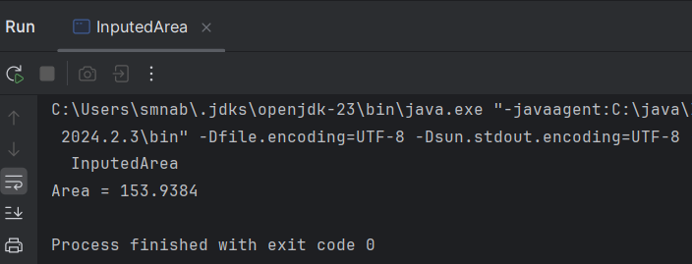
Discussion:
This program calculates and prints out the area of a circle, with a given radius. The primary purpose was to demonstrate simple mathematical operation use in Java. One refinement could be using the more precise constant Math.PI instead Pi as ‘3.1416’. This makes the calculation more accurate.
Area = Math.PI * Radius * Radius;
Conclusion:
In this lab, I learned how to calculate the area of a circle using basic Java programming techniques. The use of predefined values and then implementation of a simple formula resulted in a rather straightforward program. This lab also shows the potential for further development by the inclusion of user input and more precise mathematical constants.

Code 2: Sum of two numbers
Objective:
The objective of the lab is to develop a simple Java program that would be capable of calculating the sum of two integer numbers and then outputting the calculated sum. Such work will help understand the basic variable declaration, arithmetic operation, and output in Java.

Components Used:
1. Java Development Environment: To write, compile, and execute a Java program.
2. Variables:
“x” To hold the first integer.
“y” To hold the second integer.
“sum” To hold the result of adding x and y.
3. Arithmetic Operations: The program performs arithmetic using the operator “+” to add two integers.
4. System.out.println: In order to print output on the console.

Theory:
One of the basic arithmetic operations is addition. This consists of adding two numbers. In Java, this contains variable notation that is, naming something to store a value and it contains operator notation such as '+' that will denote the performance of an operation. The following method call, System.out.println will show to the user the result of that operation.

In this program:
Declare two integer variables x and y initializing them with 7 and 10. Use the ‘+’ operator to calculate the sum of the two integers, placing the result in a variable named sum. Finally, use System.out.println() to print this result.
In this program Sum of two numbers = 17
Example:
Input:
x = 7
y = 10
Formula:
sum = x + y = 7 + 10 = 17
Result: Sum of two numbers = 17.
Procedure of Problem Solving:
1. Declaration of Variables: Declare the data type of variables x, y and sum as int.
2. Add: This is an arithmetic operator represented by a plus symbol “+” and works on two values to result in a single value. This result of the sum is then stored in “sum”.
3. Print result: Using “System.out.println” for print the results of the sum.
4. Run: As I have written the code in above, now compile and run the program to see whether it returns an accurate sum.
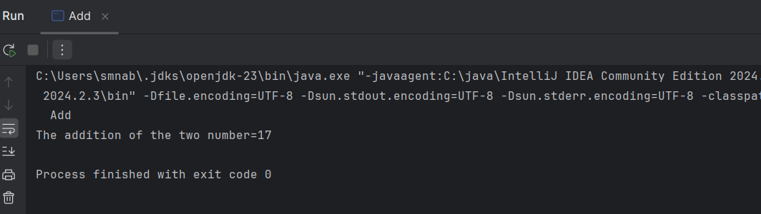

Code:

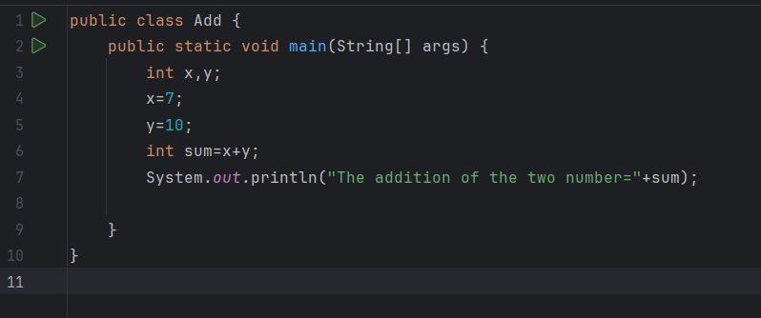
Discussion:
It is a simple Java program that declares variables, provides arithmetic operations, and handles output within Java. This will be a very good example to show beginners how the basic math operations are handled in a Java program. The following program adds two numbers and prints the output.
This example can be extended further whereby the values x and y are received as input via a Scanner making the program more interactive.
Conclusion:
In this lab, I designed a simple Java program that would input two numbers and then output the sum. The program showed how one can declare variables, add the numbers, and then print that result using the most basic constructs of Java.

Code 3 : Greater Number Program
Objective:
This lab aims to create a Java program capable of comparing two input values of integer type and determining which one is greater or if they are equal.
Components Used:
- Java Development Kit (JDK): provides the environment where the Java program will be compiled and executed.
- Java IDE: The writing and execution of Java would be done via this environment.
- Workstation: To run the program itself.
Theory:
In Java, like if-else, is used to carry out different activities based on various conditions and results of the programs. This if-else structure executes some code based upon the truthfulness or falsity of a condition.

Syntax of if-else:
if (condition) {
// Executes if condition is true
} else {
// Executes if condition is false
}

In this particular program : Declare and initialize two integer variables x and y. The program will then check if x is greater than y. In case the condition is true, it prints "X is Greater". If X is less than Y, it prints "Y", stating that Y is greater than X. If both numbers are equal, then it prints "Two are equal". Writing this program has helped explain the basic conditional logic, comparing variables, and control flow within Java.
Problem Solving Procedure:
Class: In Java, a class is a template or blueprint that other objects are created from. The class defines the fields (variables) along with the methods that may manipulate those objects. In this application, the class name is GreaterNumber and includes the code to compare two numbers.

Main Method: It is an entry point of any application in Java. This method is searched by JVM when the execution of program is started.
public : It means the method can be accessed from anywhere.
static: It allows the method to be invoked without instantiating the class.
void: It implies that the method does not return any value.
String [] args: It is used to provide arguments to the program.

Declaration of Variables: Declare two integer-type variables x and y and initialize them with any two values of your choice to be compared.

Applying Conditional Logic:
Use the if-statement to check if x is greater than y.
If true, print "X is Greater".
Using else if, check if y is greater than x.
If true, print "Y".
As both the above conditions are not satisfying, it means both numbers are equal, hence print "Two are equal".
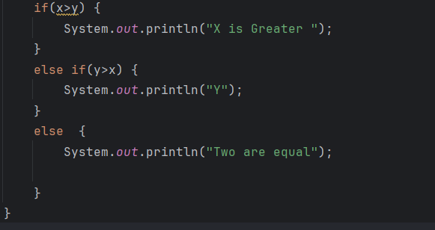

Output Run the Program: Compile and then run the program to view the output.

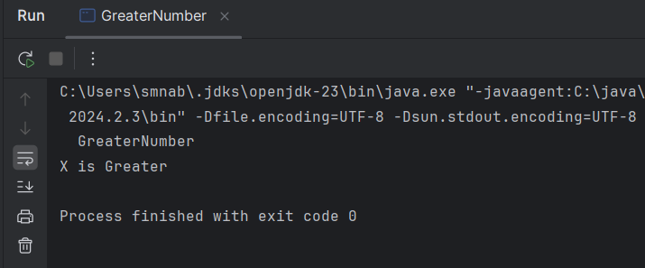
Input & Output:
Input:
The program has two input values:
- x = 10
- y = 5

Output:
The program shows output:
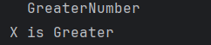

Code:
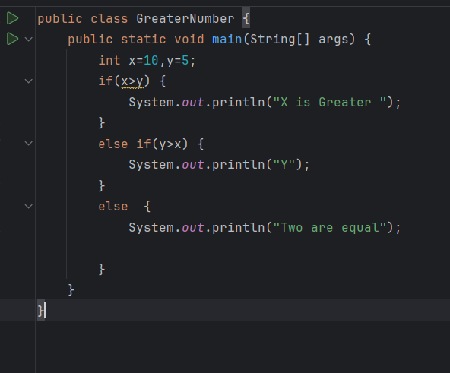

Discussion:
This program compares two integer values x and y and prints out whether x is greater. y is greater or whether they are equal. It does this using an if-else conditional structure that will be checking conditions of the program:

1. If x > y, it prints "X is Greater".
2. If y > x, then it prints "Y is Greater".
3. If none of the above conditions is true, in other words x == y it prints "Two are equal".
The above piece of code demonstrates simple decision making through conditional statements in Java. This is done in constant time ZERO(0). Because it performs no more than three comparisons.
Conclusion:
This lab report through a simple if-else structure in Java that compares two numbers and prints related outputs based on the values. The code is efficient and easy to understand. So it can be help us for solving more complex cases.

